AVC Maze

# Overview:

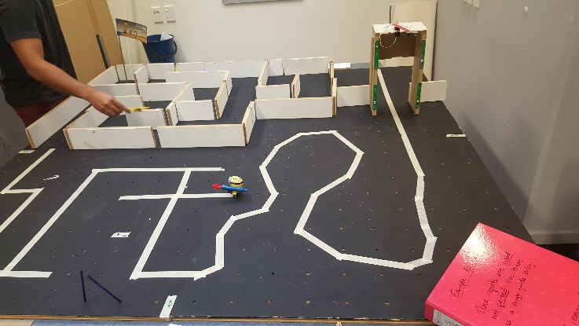

# Quadrant 1:

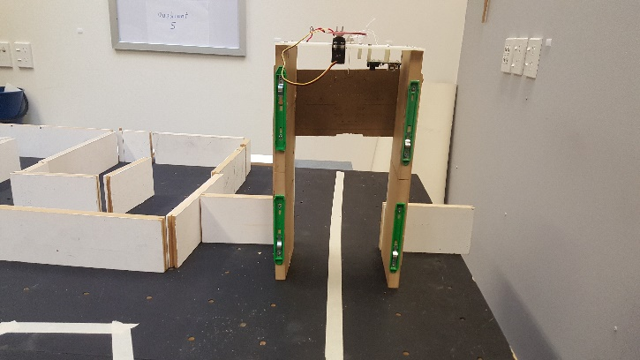

**Description:** Straight taped path, blocked by a gate opened by network commands.  
**Strategies:** Follow the white tape, stopping when near the gate, sending the network command to open the gate, and continuing along the white tape.  
**Hardware required:**

* Wheels
* Motors
* Camera (for sensing white tape)
* Distance sensor (for sensing gate)

# Quadrant 2:

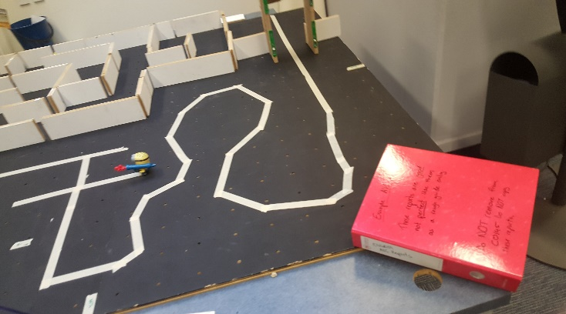

**Description:** Curved path  
**Strategies:** Follow the white tape, if white tape is lost; reverse and try again.  
**Hardware required:**

* Wheels
* Motors
* Camera (for sensing white tape)

# Quadrant 3:

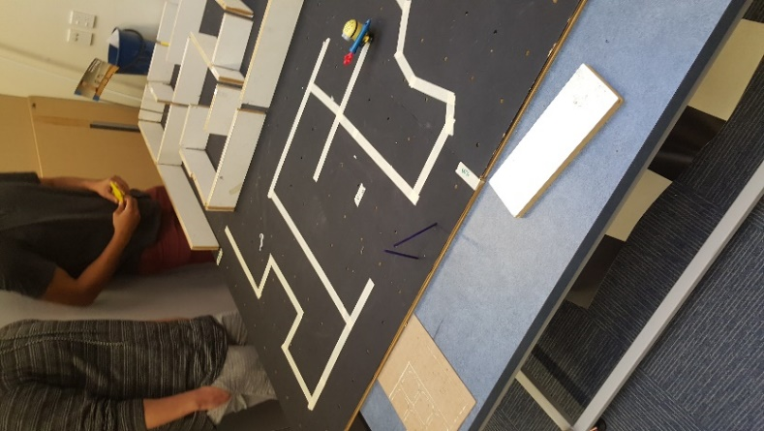

**Description:** Straight tape paths with sharp intersections and corners.  
**Strategies:** Follow the white tape, if white tape is lost; reverse and try again. Sense dead ends and turn around, sense sharp turns, and turn appropriately.  
**Hardware required:**

* Wheels
* Motors
* Camera (for sensing white tape)

# Quadrant 4:

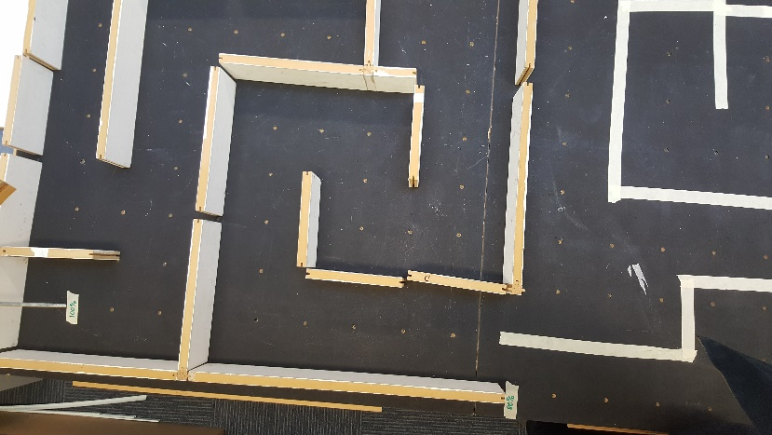

**Description:** Tape ends, corridors with high walls either side, sharp corners, intersections, and dead ends.  
**Strategies:** Use the “wall follower” maze solving algorithm (by following the left wall).

**Hardware required:**

* Wheels
* Motors
* Camera (for sensing white tape)
* Distance sensors (for sensing the left wall, as well as directly directly in front of the robot)

# Quadrant 5:

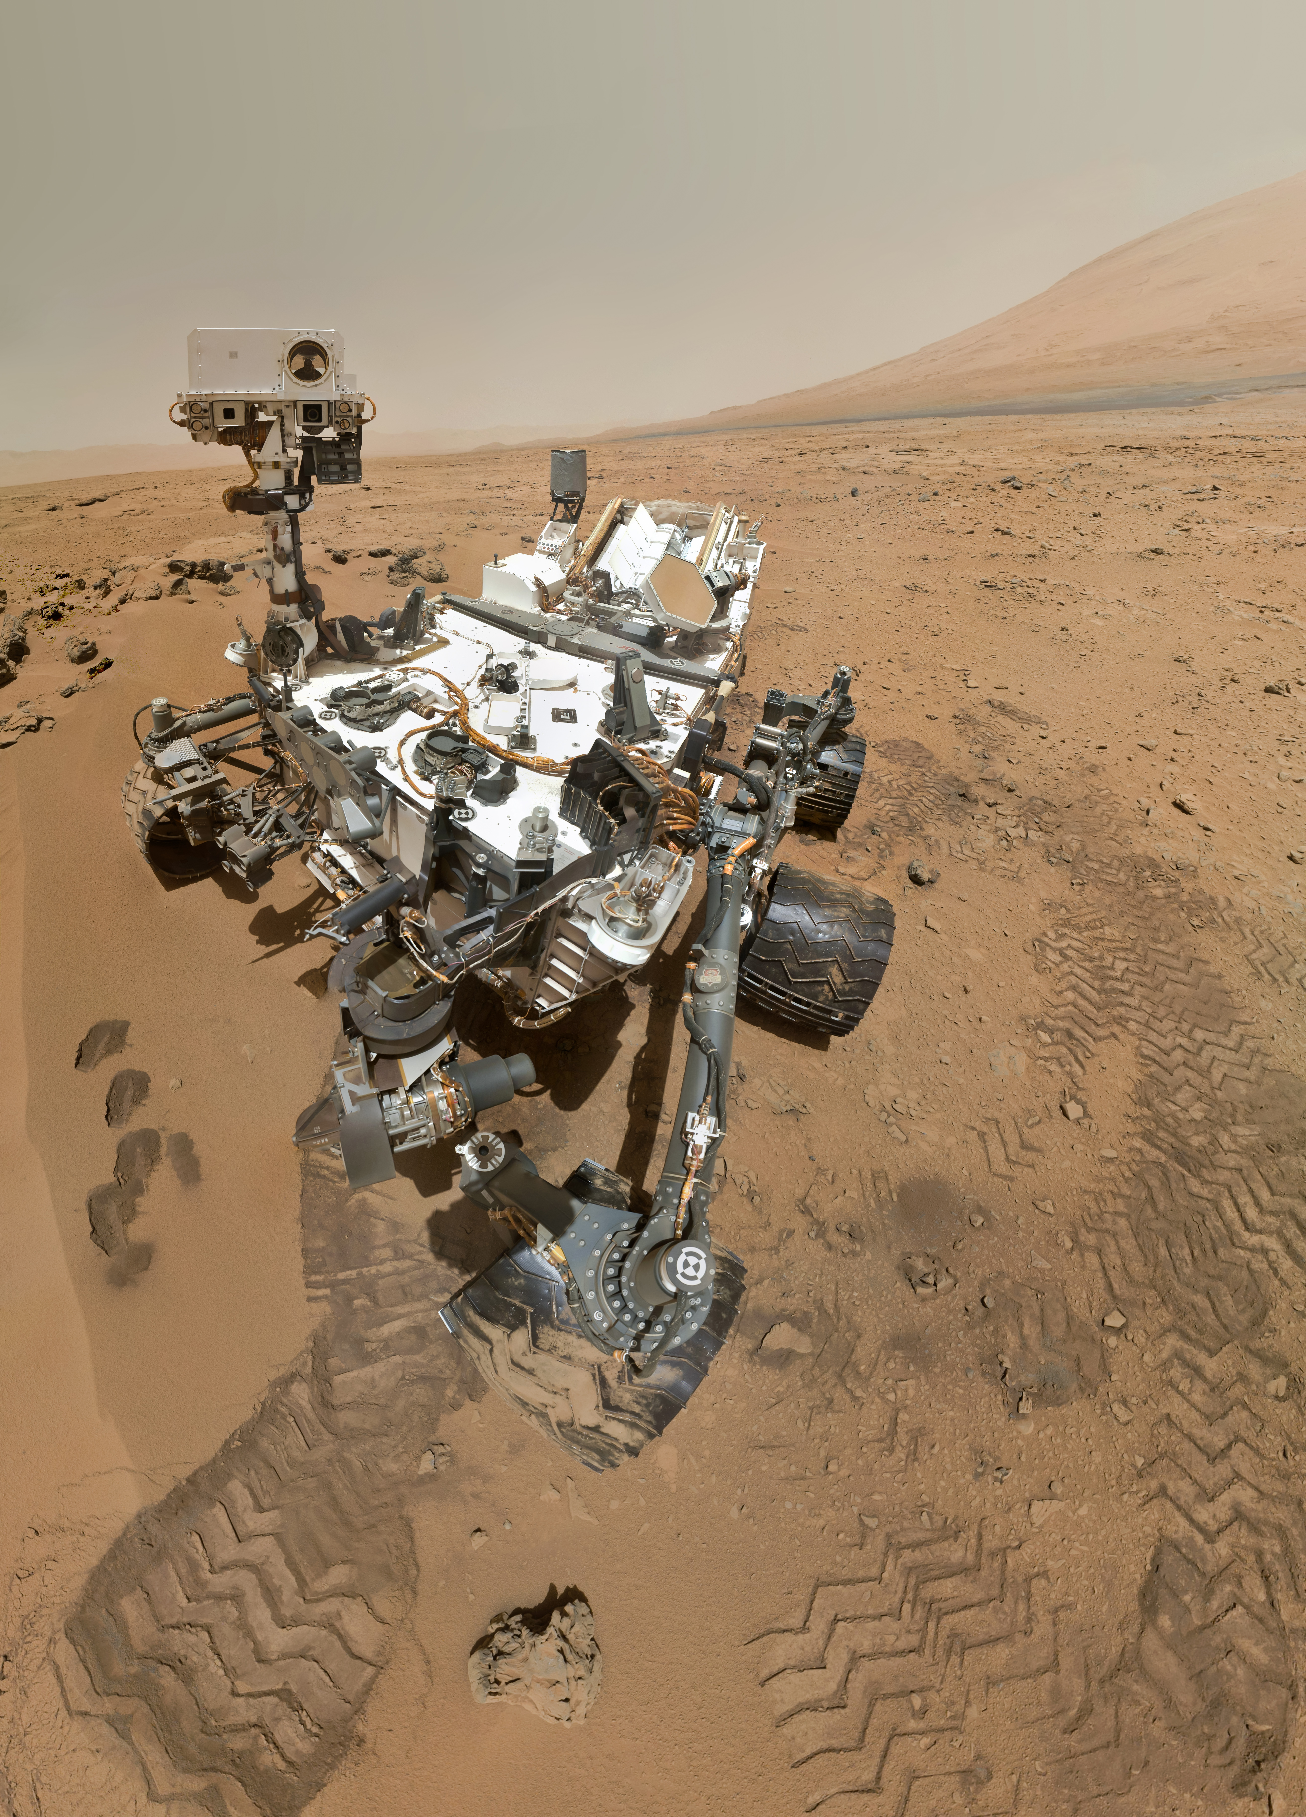

**Description:** Mars.  
**Strategies:** Use rockets to escape both the lab and the atmosphere, and make its way to mars.  
**Hardware required:**

* Rockets
* Enough rocket fuel to escape atmosphere
* Parachute